LVMR website modifications

- Change this photo
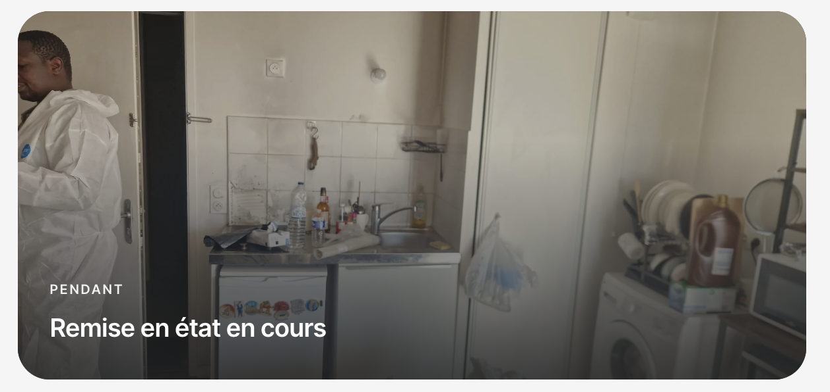

With this one named LVMRRR
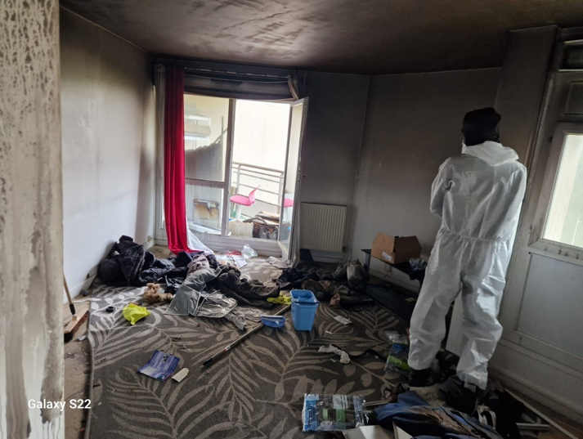

- Can you put the same little white backgroung on the logo here on the homepage for LVMR environnment ? good idea from you !



- Can you delete the dark effect on the back ? if we don’t see enough the writing we can put a white effect on the left for each first section what do you think ? And why did you change this photo on the homepage ?


